**Ubuntu Desktop**

**What is Ubuntu?**

Ubuntu is a Linux distribution based on Debian and composed mostly of free and open-source software. Ubuntu is officially released in three editions: Desktop, Server, and Core for Internet of things devices and robots

Starting Ubuntu With the installation process.

But before installation of ubuntu desktop, we need to install Virtual box .

Virtual Box is cross-platform virtualization software. It allows users to extend their existing computer to run multiple operating systems including Microsoft Windows, Mac OS X, Linux, and Oracle Solaris, at the same time.

Here I installed Oracle VM VirtualBox followed my ubuntu software.

Here’s We are starting with ubuntu.

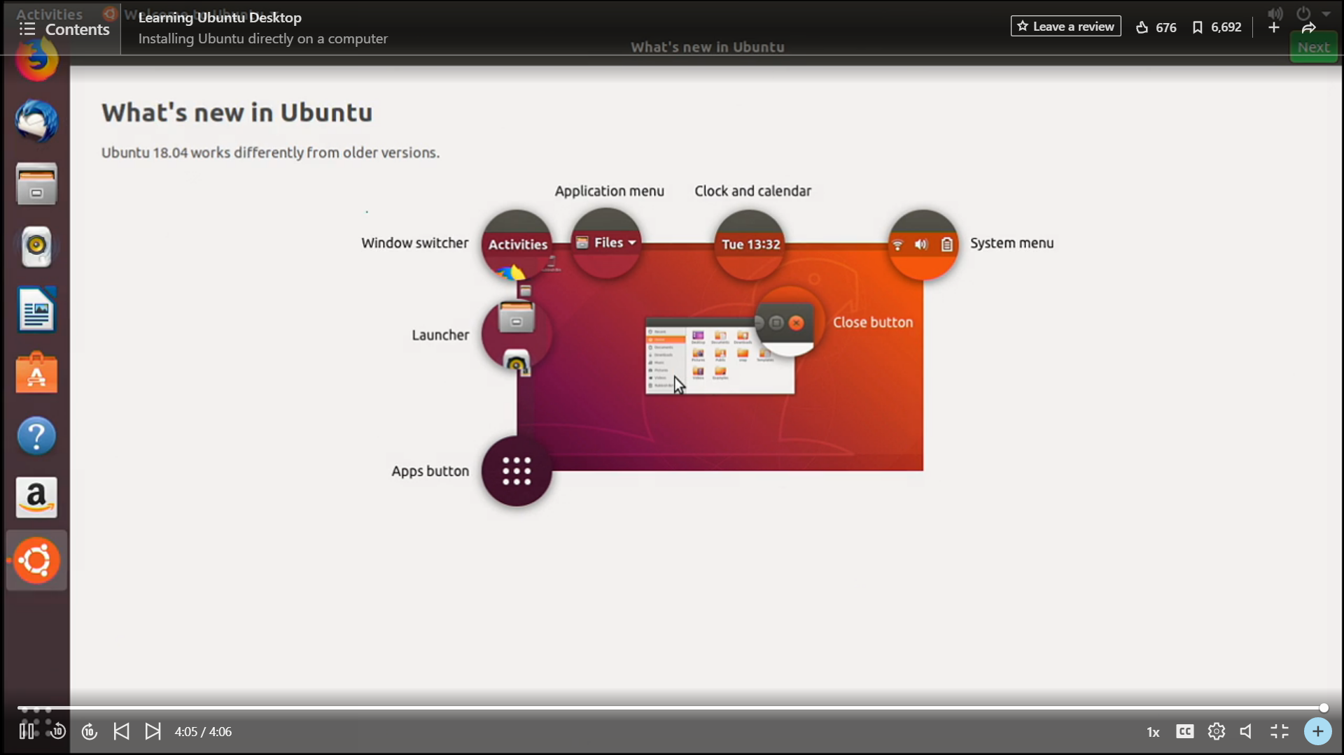

**Activities in left corner where I can Search programs.**

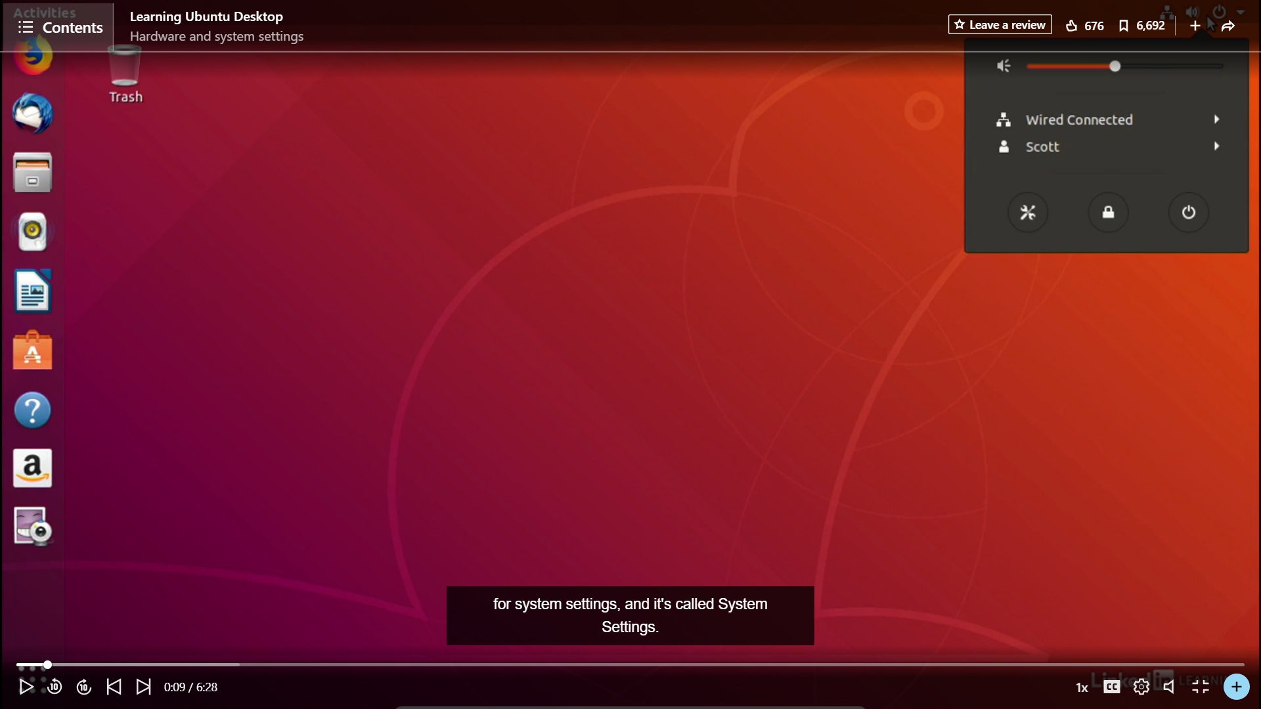

Here is shown the setting through which we can change the appearance or any connection whether it may to connect bluetooth wifi search anything or access any files or folders.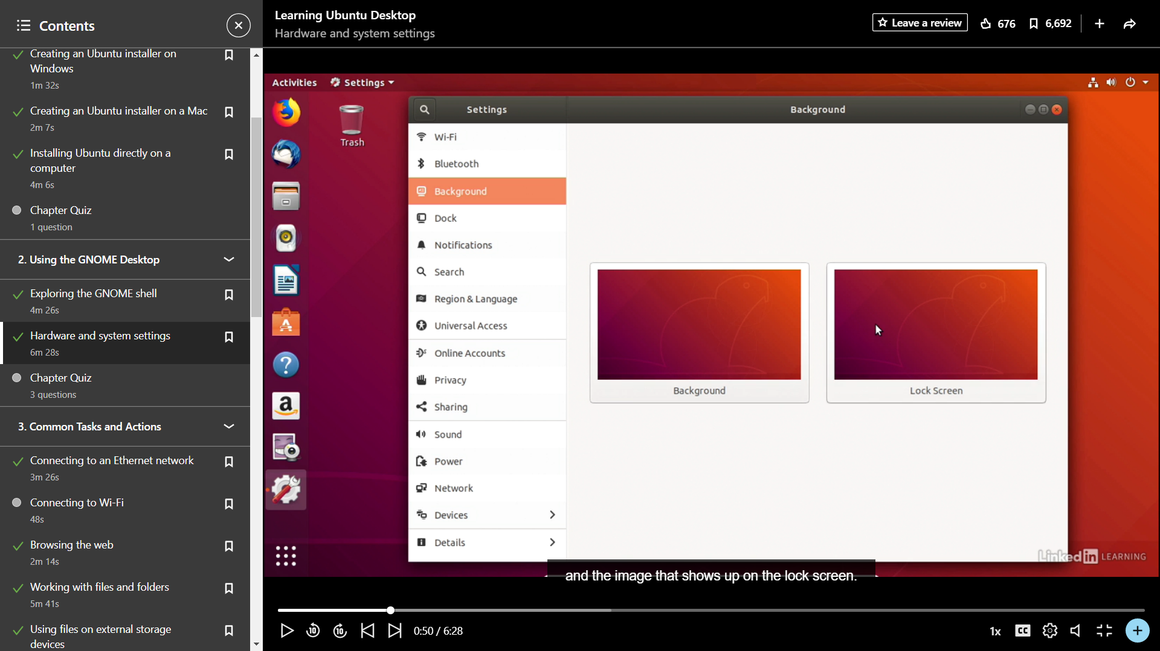

**Adding new Software through ubuntu software.**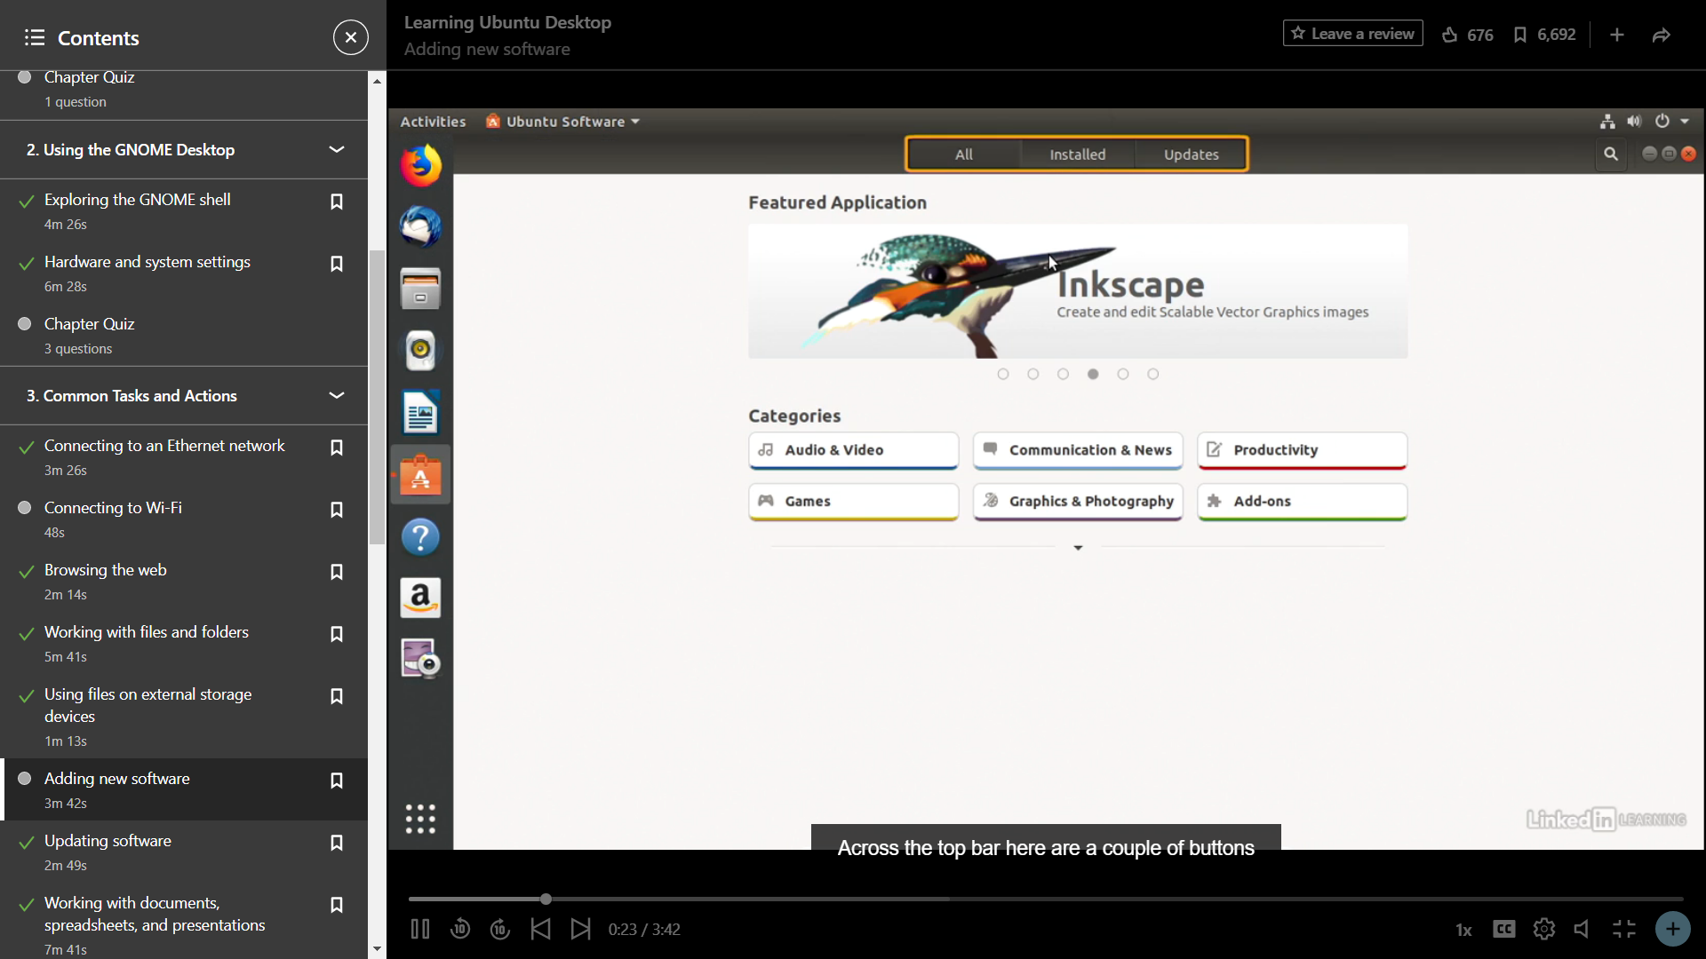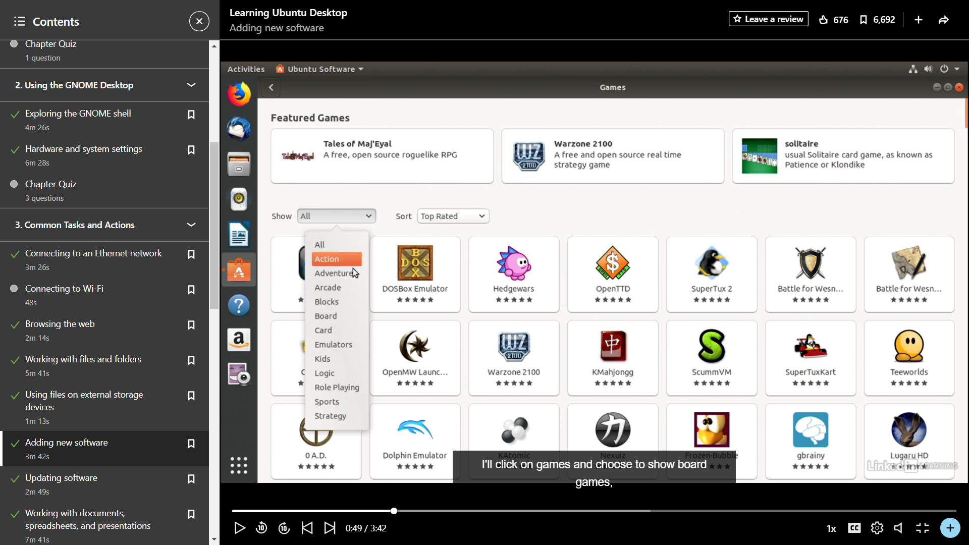

**Updating software**

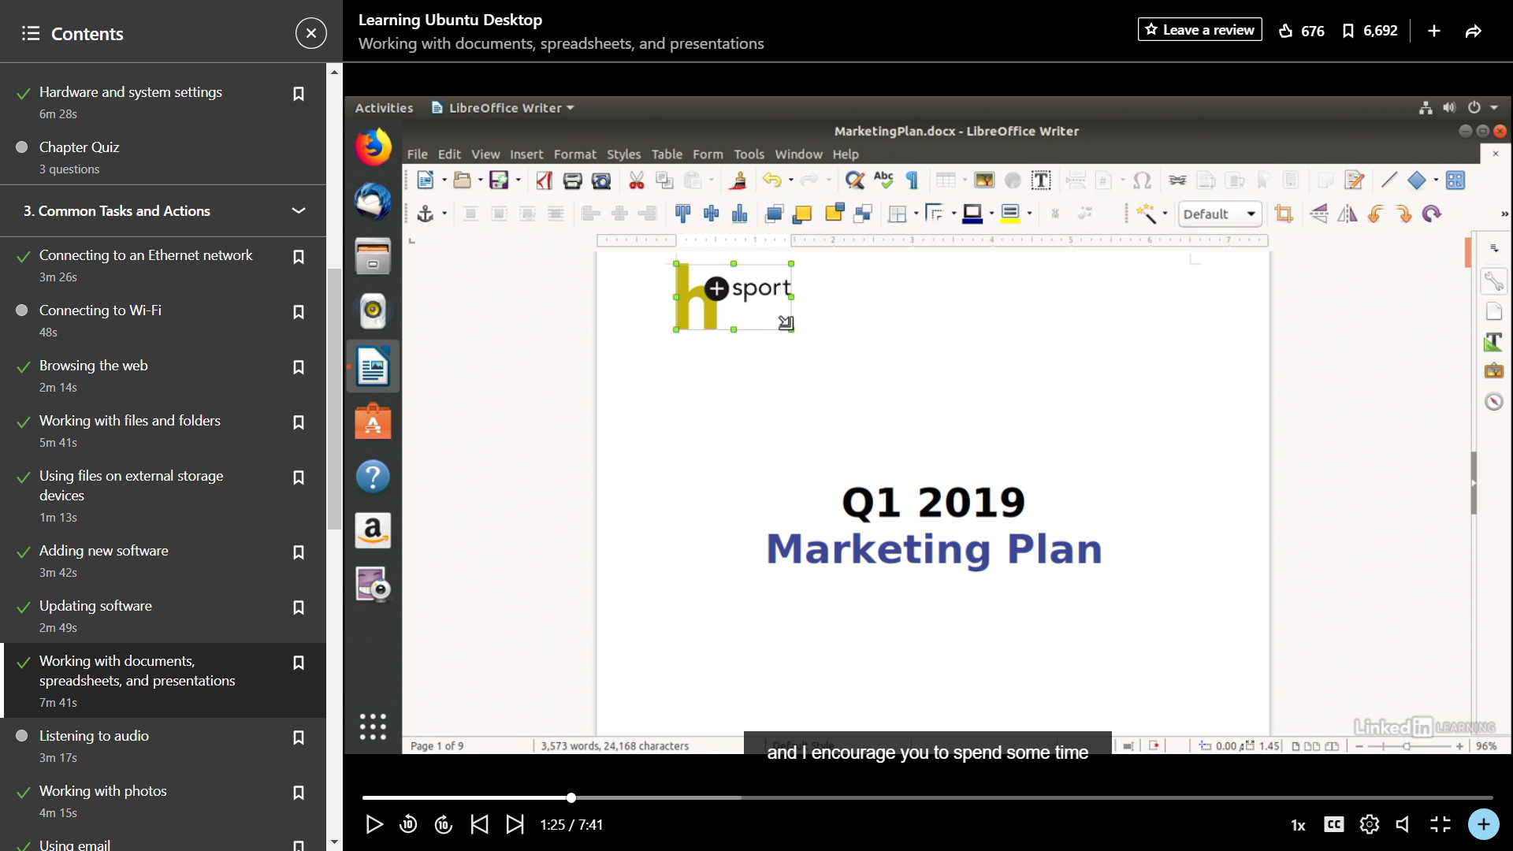

Backing up data: If we lost are data there should to be a backup and here that’s the benefit of ubuntu.

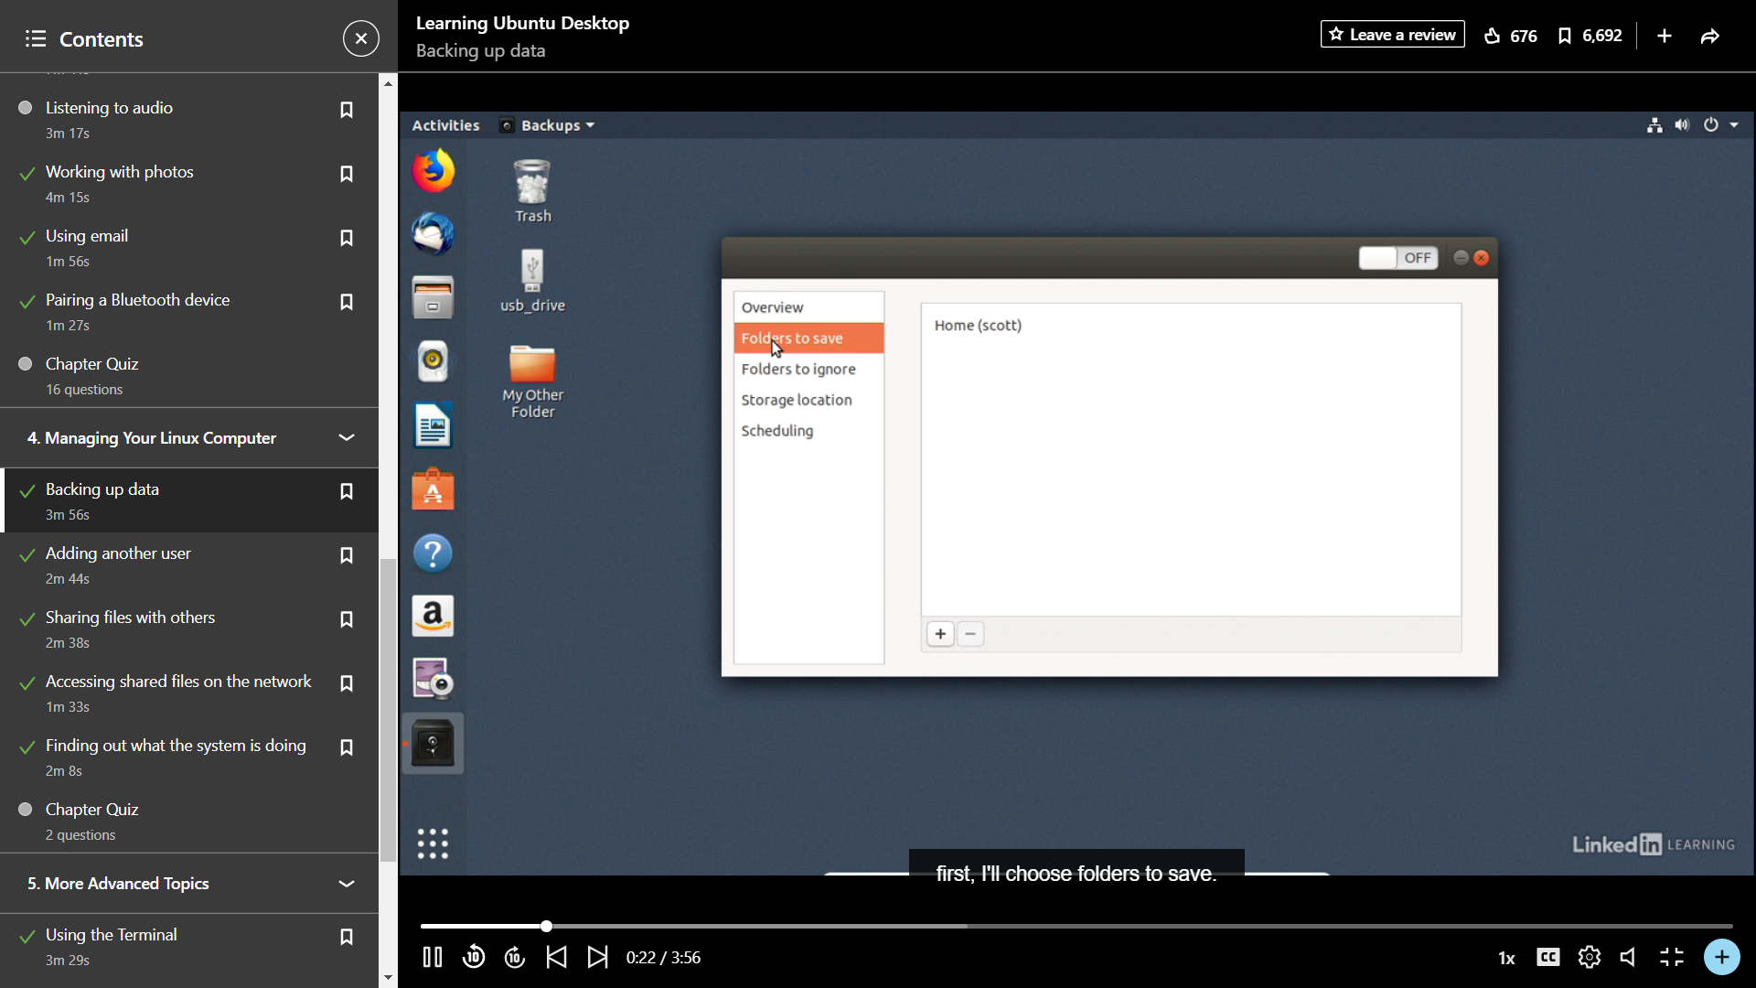

**Adding new user:** 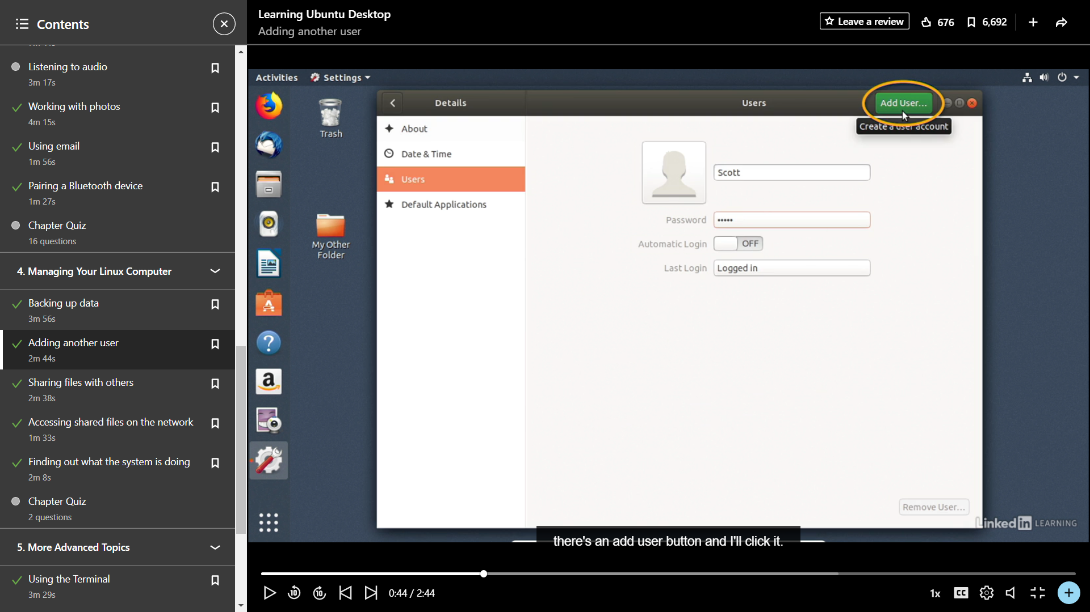

**Accessing files and folders**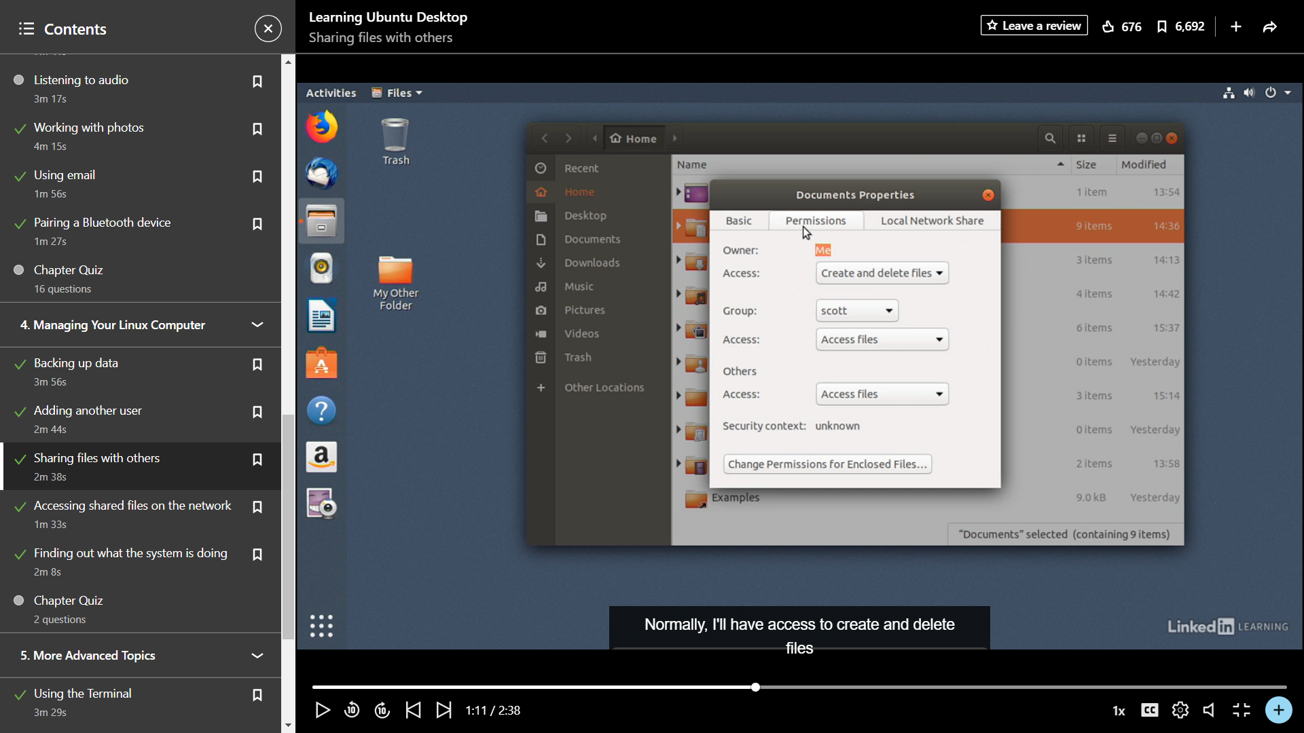

**Accessing shared files on Internet**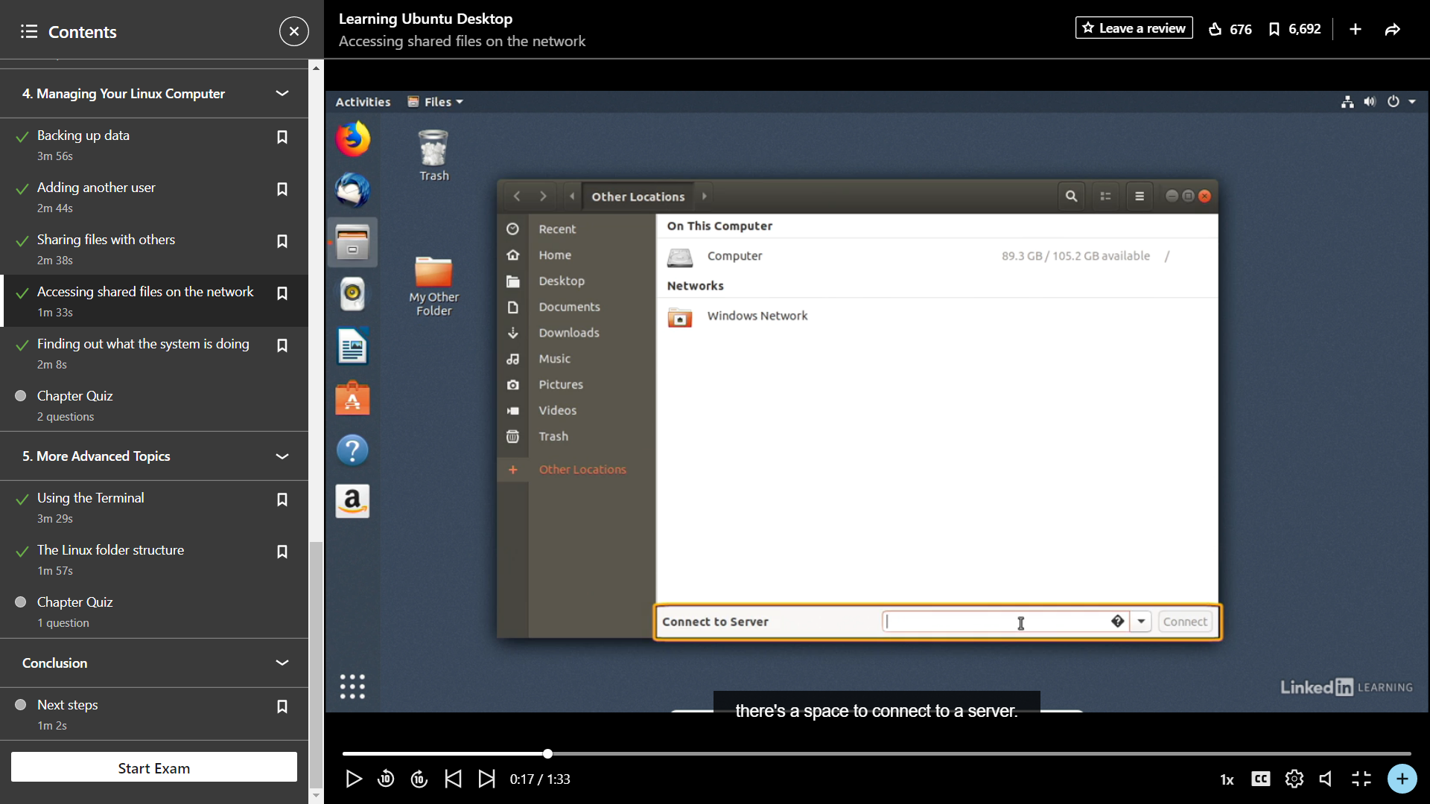

The last is the Linex terminal as it also have CLI(Command line Interface) which is easy to use while using some commands and makes change to the desktop.